Time | Monday |  | Tuesday | Wednesday | Thursday | Friday | Saturday | Sunday
7:30 am  (50 Min.) |  |  | 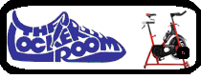
7:45 am
(40 Min.)
8:15 am | 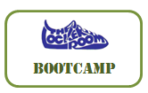
9:00am | 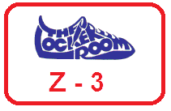 |  | 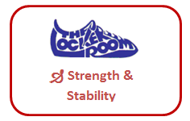 |  |  | 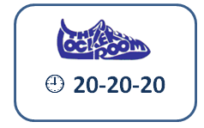 | .
10:00am |  |  |  |  |  |  | 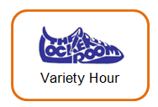 | Like us on Facebook and Twitter for the most up to date information
10:30am | 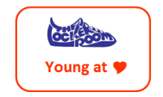  (45min) |  | * | (45min) | 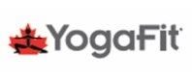  * | 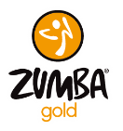  (45min)
12:10  (40 Min.) |  |  |  | 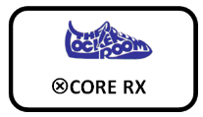 |  |  | Go to: www.  thelockerroom.ca to download the Saturday Rotation Schedule, a copy of this schedule and to check out special events.
5:30pm | (40 Min.) |  |  | (45min)
6:30pm |  |  | 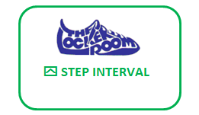 | (40 Min.)
7:30pm | * |  | 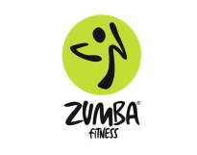 | *
Class Descriptions are listed below. Regular classes are included in membership. Non-member Drop in $5.00 hst in. YogaFit™ classes Drop in Fee $10.00 +hst
Group Cycling Join us for our newest Group Fitness Experience! We’ve purchases 10 brand new Louis Garneau cycling bikes, specifically for this class! Burn calories, build muscle, and relieve stress! Indoor cycling is a motivating group exercise class performed on a specialized stationary bicycle. It is fun, accessible and effective! Max 9 participants - You may reserve your bike for class 24 hours ahead of time. Class space is limited and on a “First come first served” basis. Please allow 5 minutes before class begins to set up your bike.

NEW
 |  | BOOTCAMP Push yourself and unleash your inner athlete. This BOOTCAMP format will focus on High Intensity Interval Training with lots to work (& not much rest) to maximize caloric energy expenditure. This class pushes you a little harder than you might think you can work. Class includes a variety of drills, plyometric exercises, & circuits using various types of equipment. The atmosphere is infectious with an awesome personal trainer & fitness instructor coaching you through to the end! What a great way to kick start your day!
 |  | BOOTCAMP lite Perfect for the beginner, deconditioned or older adult. Low impact, Moderate to high intensity. This class will push you to your fitness best! Various drills, circuits, and equipment will keep you guessing and your muscles working.
This 60-minutes class consists of:
20 minutes of high & low impact cardio, 20 minutes of Step, plus 20 minutes of resistance & flexibility training = 60 minutes of FUN!A Club Favourite with members!
Following STEP Reebok guidelines, this class alternates cardio work on a STEP platform with resistance training.
Weights, tubing, gliders, bands & balls may be incorporated into class.
Check out our website to download our Intro to Stepping Handout ! www.thelockeroom.ca
 |  | This 60-minute class focuses on training the entire body for activities of daily living. Use of Reebok Core Boards, BOSU Trainers, wobble boards, medicine balls, tubing, weights and foam rollers will enhance the training effect. Strengthen your body – make it Stable& Strong!
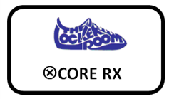 |  | Core RX is a functional strength and toning program designed to improve your waistline! The focus will be on stabilizing the torso, while moving the body through various exercises that rotate the hips, the spine, the back, the shoulders and legs! An efficient and effective workout!
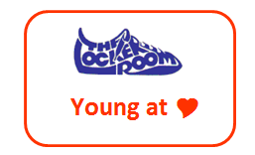 |  | This program is designed for the 55-plus age group. This class combines basic FUNctional strength training with cardiovascular exercise plus flexibility movements for your overall health and wellness, and to keep you feeling Young at Heart!
Combine 3 Zumba® Styles into one class…you get Z - 3!
Dance, Tone and Strengthen in a fun class full of Zumba® Style, Fun and Fitness. A Zumba® enthusiast’s dream class! Styles are Zumba®Basic™ Zumba®Toning™ Zumba® Santao™
 |  | This Saturday Morning Group Exercise Class will change format with each instructor from week to week. Experience the various fun and unique ways to get a great workout. All fitness levels can participate! Please see calendar in lobby for class/instructor schedule or download the schedule at www.thelockerroom.ca Special Guest Instructors will be presenting such classes as Nia…be sure to check it out!
 |  | Zumba® classes feature exotic rhythms set to high-energy Latin and international beats. Before participants know it, they’re getting fit and their energy levels are soaring! There’s no other fitness class like a Zumba® Fitness-Party. It’s easy to do, effective and totally exhilarating!
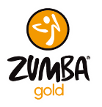 |  | Zumba® Gold Zumba Gold targets the largest growing segment of the population: baby boomers. It takes the Zumba formula and modifies the moves and pacing to suit the needs of the active older participant, as well as those just starting their journey to a fit and healthy lifestyle.
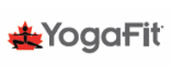 |  | The Locker Room is proud to present the YogaFit program at the club. This program is designed for group fitness enthusiasts and is inclusive for all levels of experience. YogaFit focus is on you experiencing the yoga postures and exercises from a place of non-judgement, acceptance and inclusion. This wonderful program is reduced in price with your membership, and available to your friends and neighbors at non-member rates.
 |  | Group RX – RIP! RIP is a group barbell program for men and women of all ages. This program caters to all fitness levels by keeping it simple with athletic movements such as squats, lunges, chest presses and bicep curls. It is choreographed to great music and is designed to be achievable by the average person, yet allows seasoned lifters and other well-conditioned athletes to work at their level. The Rip Program uses exercises from traditional strength training and matches the movement to music to create a simple, fun and effective way to strength train.

